COVID-19 in India: State-wise

12/1/2020

Rishob Ghosh

CONTENT

List of FigureS 2

COVID - 19 Pandemic in INDIA 3

Timeline 4

Countermeasures 5

Testing 5

Initial testing 5

Testing community transmission 6

Research and treatment 7

Development of anti-COVID vaccines 7

Statistics 8

Charts 11

LIST OF FIGURES

**Figure 1. India Covid Demographic view**…………………………………………………………………………

10

**Figure 2. Confirmed cases vs Population…………………………………………………………………..**.

10

**Figure 3. Confirmed cases vs Recovered**………………………………………………………………………….

11

**Figure 4. Confirmed cases vs Deaths………………………………………………………………………….**.

11

# COVID 19 PANDEMIC IN INDIA

The COVID-19 pandemic in India is part of the worldwide pandemic of coronavirus disease 2019 (COVID-19) caused by severe acute respiratory syndrome coronavirus 2 (SARS-CoV-2). The first case of COVID-19 in India, which originated from China, was

reported on 30 January 2020. India currently has the largest number of confirmed cases in Asia, and has the second-highest number of confirmed cases in the world after the

United States, with the number of total confirmed cases breaching the 100,000 mark on 19 May, and 1,000,000 confirmed cases on 17 July 2020. On 29 August 2020, India

recorded the global highest single-day spike in COVID-19 cases with 78,761 cases, surpassing the previous record of 77,368 cases recorded in the US on 17 July 2020. India currently holds the single day record for largest increase in cases, set on September 17, with an additional 97,894 and has sustained highest number of daily cases spike since then. September 25 marked 1.49 million tests in a single day; the highest in the world

On 22 March, India observed a 14-hour voluntary public curfew at the insistence of Prime Minister Narendra Modi. It was followed by mandatory lockdowns in COVID-19 hotspots and all major cities. Further, on 24 March, the prime minister ordered a nationwide lockdown for 21 days, affecting the entire 1.3 billion population of India. On

14 April, India extended the nationwide lockdown till 3 May which was followed by two-week extensions starting 3 and 17 May with substantial relaxations. From 1 June, the government started "unlocking" the country (barring "containment zones") in three unlock phases.

# TIMELINE

On 30 January, India reported its first case of COVID-19 in Kerala, which rose to three cases by 3 February; all were students returning from Wuhan. Apart from these, no significant rise in transmissions was observed in February. On 4 March 22 new cases were reported, including 14 infected members of an Italian tourist group.

In March, the transmissions grew after several people with travel history to affected countries, and their contacts, tested positive. On 12 March, a 76-year-old man, with a travel history to Saudi Arabia, became the first COVID-19 fatality of India.

A Sikh preacher, who had a travel history to Italy and Germany, turned into a "super spreader" by attending a Sikh festival in Anandpur Sahib during 10–12 March. Twenty-seven COVID-19 cases were traced back to him.[48] Over 40,000 people in 20 villages in Punjab were quarantined on 27 March to contain the spread.

On 31 March, a Tablighi Jamaat religious congregation event in Delhi, which had taken place earlier in March, emerged as a new virus super spreader event, after numerous cases across the country were traced back to it. On 18 April, the Health ministry announced that 4,291 cases were directly linked to the event.

On 2 May, in Punjab, around 4,000 stranded pilgrims returned from Hazur Sahib in Nanded, Maharashtra. Many of them tested positive, including 27 bus drivers and

conductors who had been part of the transport arrangement. As of 13 May, 1,225 pilgrims had been tested positive.

# COUNTERMEASURES

Closing nonessential businesses and schools and restricting borders are among the

most effective measures that governments can impose to reduce the rate of Covid-19

transmission, a new study finds, showing the effectiveness of strict measures, but the

research also points to less intrusive alternatives as governors across the country re

impose amid a nationwide surge in coronavirus cases.

# TESTING

On 14 March, scientists at the National Institute of Virology isolated a strain of the novel

coronavirus. By doing so, India became the fifth country to successfully obtain a pure

sample of the virus after China, Japan, Thailand and the US. The Indian Council of

Medical Research (ICMR) said that isolation of the virus will help towards expediting the

development of drugs, vaccines and rapid diagnostic kits in the country. NIV has shared

two SARS-CoV-2 genome sequences with GISAID. On 16 April, China sent 650,000

testing kits to India but their use was discontinued in view of a very low accuracy (of just

%). In May, National Institute of Virology introduced another antibody test kit ELISA

for rapid testing, capable of processing 90 samples in a single run of 2.5 hours.

# INITIAL TESTING

Initially, the labs tested samples only from those with a travel history to 12 countries

designated as high-risk, or those who have come in contact with anyone testing positive

for the coronavirus, or showing symptoms as per the government guidelines. On 20

March, the government decided to also include all pneumonia cases, regardless of

travel or contact history after the country saw a sharp increase in the number of cases.

The first and second confirmatory tests for the virus has been made free by the

government. On 9 April, ICMR further revised the testing strategy and allowed testing of

the people showing symptoms for a week in the hotspot areas of the country, regardless

of travel history or local contact to a patient.

# TESTING COMMUNITY TRANSMISSION

Testing for community transmission began on 15 March. 65 laboratories of the

Department of Health Research and the Indian Council of Medical Research

(DHR-ICMR) have started testing random samples of people who exhibit flu-like

symptoms and samples from patients without any travel history or contact with infected

persons. As of 18 March, no evidence of community transmission was found after

results of 500 random samples tested negative.

Between 15 February and 2 April, 5,911 SARI (Severe Acute Respiratory Illnesses)

patients were tested throughout the country of which 104 tested positive (1.8%) in 20

states and union territories. About 40% of the identified patients did not have travel

history or any history of contact with a positive patient. The ICMR advised priority

containment in the 36 districts of 15 states which had reported positive cases among

SARI patients. Till the third quarter of the year, India had attained the highest number of

daily tests in the world

.

# RESEARCH AND TREATMENT

According to estimates, India has around 40,000 ventilators, of which 8,432 are with the public sector. Various Indian PSUs, firms and startups, including DRDO and ISRO, have since repurposed their production lines to manufacture general PPEs, full body suits and ventilators. They are also designing low-cost or mobile medical equipment.

The focus was to increase the production of low-cost, compact and portable ventilators that could cater to multiple patients at a time. This led to the creation of some of the

world's smallest and cheapest ventilators. The government aims to double the current capacity of ventilators by June 2020 with the assistance from PSUs. The government has also requested major private automakers to explore the possibility of manufacturing ventilators at their plants. Maruti Suzuki, in collaboration with AgVa Healthcare, will supply 10,000 ventilators till the end of May. From nil in the near past, India was producing around 200,000 PPE kits and 250,000 N95 masks per day in May 2020. By the second half of month, India had emerged as world's second largest producer of PPE body coveralls.

The Centre for Cellular and Molecular Biology has been working on genome sequencing of COVID-19. In May, CCMB also started a partnership with a private company Eye stem Research to grow novel coronavirus strain in human lung epithelial cells for research and trials of antiviral drugs.

# DEVELOPMENT OF ANTI COVID VACCINES

Pune-based Serum Institute of India announced that it would apply for clinical trials of certain strains from Drug Controller General of India (DCGI) in April. As per company

president Adar Poonawalla, a vaccine for COVID-19 will be delivered within a year. However, it may not be effective on 20 to 30% people. Two other companies are also trying to develop a vaccine: Zydus Cadila, which is replicating viral vector and developing a DNA plasmid vaccine, and Hyderabad-based Bharat Biotech, in collaboration with US based Fulgent, which is expecting the first clinical trials of a nasal vaccine by late 2020. As of late February, the Serum Institute of India had begun animal trials of vaccine candidates, followed by Zydus Cadila in March. ICMR partnered with Bharat Biotech in May to develop COVID vaccine completely in India.

Till May, there were over 30 candidates of COVID-19 vaccine in development in India, many of which were already in preclinical tests. Per reports emerged in July, ICMR was preparing to launch BBV152 COVID vaccine or Covaxin, India's first COVID-19 vaccine on 15 August following its ongoing human trials in July. Although, later deadline was cited as only meant to cut "red tape" and the expected timeline of any Indian vaccine not to be before 2021. COVEXIN has been reported to have positive results on animals in building immunity against COVID-19 in pre-clinical trials. In mid-July, Zydus Cadila too had followed with human trials of its vaccine named ZyCoV-D. In early August, SII's got approval from DCGI for trial phases II & III. SII has also joined GAVI in a partnership with Bill & Melinda Gates Foundation to produce 100 million doses of vaccine for developing countries.

# STATISTICS

|  |  |  |  |  |  |
| --- | --- | --- | --- | --- | --- |
| **State** | **Confirmed** | **Active** | **Recovered** | **Deaths** | **Population** |
| **Andaman and Nicobar Islands** | 3,912 | 180 | 3,678 | 54.00 | 380581 |

|  |  |  |  |  |  |
| --- | --- | --- | --- | --- | --- |
| **Andhra Pradesh** | 7,29,307 | 50,776 | 6,72,479 | 6,052 | 84580777 |
| **Arunachal Pradesh** | 11,007 | 3,022 | 7,965 | 20 | 1383727 |
| **Assam** | 1,88,902 | 33,047 | 1,55,077 | 778 | 31205576 |
| **Bihar** | 1,90,740 | 11,420 | 1,78,395 | 925 | 104099452 |
| **Chandigarh** | 12,707 | 1,492 | 11,035 | 180 | 25545198 |
| **Dadra and Nagar Haveli and Daman and Diu** | 3,103 | 101 | 3,000 | 2 | 243247 |
| **Delhi** | 2,95,236 | 22,720 | 2,66,935 | 5,581 | 16787941 |
| **Goa** | 36,238 | 4,720 | 31,050 | 468 | 1458545 |
| **Gujarat** | 1,45,200 | 16,570 | 1,25,111 | 3,519 | 60439692 |
| **Haryana** | 1,36,115 | 11,320 | 1,23,286 | 1,509 | 25351462 |
| **Himachal Pradesh** | 16,283 | 3,136 | 12,918 | 229 | 6864602 |
| **Jammu and Kashmir** | 80,476 | 13,712 | 65,496 | 1,268 | 12541302 |
| **Jharkhand** | 88,873 | 10,027 | 78,089 | 757 | 32988134 |

|  |  |  |  |  |  |
| --- | --- | --- | --- | --- | --- |
| **Karnataka** | 6,57,705 | 1,15,170 | 5,33,074 | 9,461 | 61095297 |
| **Kerala** | 2,42,799 | 87,823 | 1,54,092 | 884 | 33406061 |
| **Ladakh** | 4,720 | 1,195 | 3,464 | 61 | 2,74,000 |
| **Lakshadwee p** | 0 | 0 | 0 | 0 | 64473 |
| **Madhya Pradesh** | 1,38,668 | 18,141 | 1,18,039 | 2,488 | 72626809 |
| **Maharashtra** | 14,65,911 | 2,47,468 | 11,79,726 | 38,717 | 112374333 |
| **Manipur** | 12,240 | 2,680 | 9,482 | 78 | 2855794 |
| **Meghalaya** | 7,037 | 2,371 | 4,606 | 60 | 2966889 |
| **Mizoram** | 2,148 | 261 | 1,887 | 0 | 1097206 |
| **Nagaland** | 6,662 | 1,185 | 5,460 | 17 | 1978502 |
| **Odisha** | 2,38,003 | 26,846 | 2,10,217 | 940 | 41974218 |
| **Puducherry** | 29,682 | 4,522 | 24,614 | 546 | 1247953 |
| **Punjab** | 1,20,016 | 11,982 | 1,04,355 | 3,679 | 27743338 |
| **Rajasthan** | 1,48,316 | 21,294 | 1,25,448 | 1,574 | 68548437 |
| **Sikkim** | 3,216 | 580 | 2,587 | 49 | 610577 |

|  |  |  |  |  |  |
| --- | --- | --- | --- | --- | --- |
| **Tamil Nadu** | 6,30,408 | 45,279 | 5,75,212 | 9,917 | 72147030 |
| **Telangana** | 2,04,748 | 26,551 | 1,77,008 | 1,189 | 3,52,00,000 |
| **Tripura** | 27,545 | 4,621 | 22,623 | 301 | 3673917 |
| **Uttarakhand** | 52,329 | 8,414 | 43,238 | 677 | 199812341 |
| **Uttar Pradesh** | 4,20,937 | 44,031 | 3,70,753 | 6,153 | 10086292 |
| **West Bengal** | 2,77,049 | 27,988 | 2,43,743 | 5,318 | 91276115 |

# CHARTS

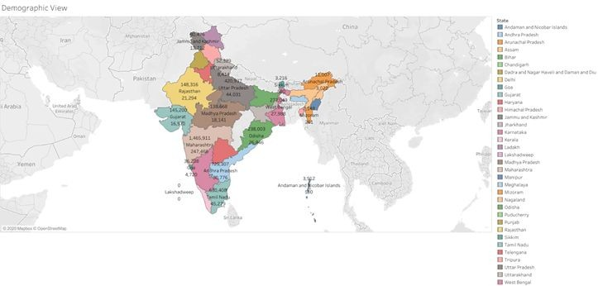

**Fig 1 : demographic view**

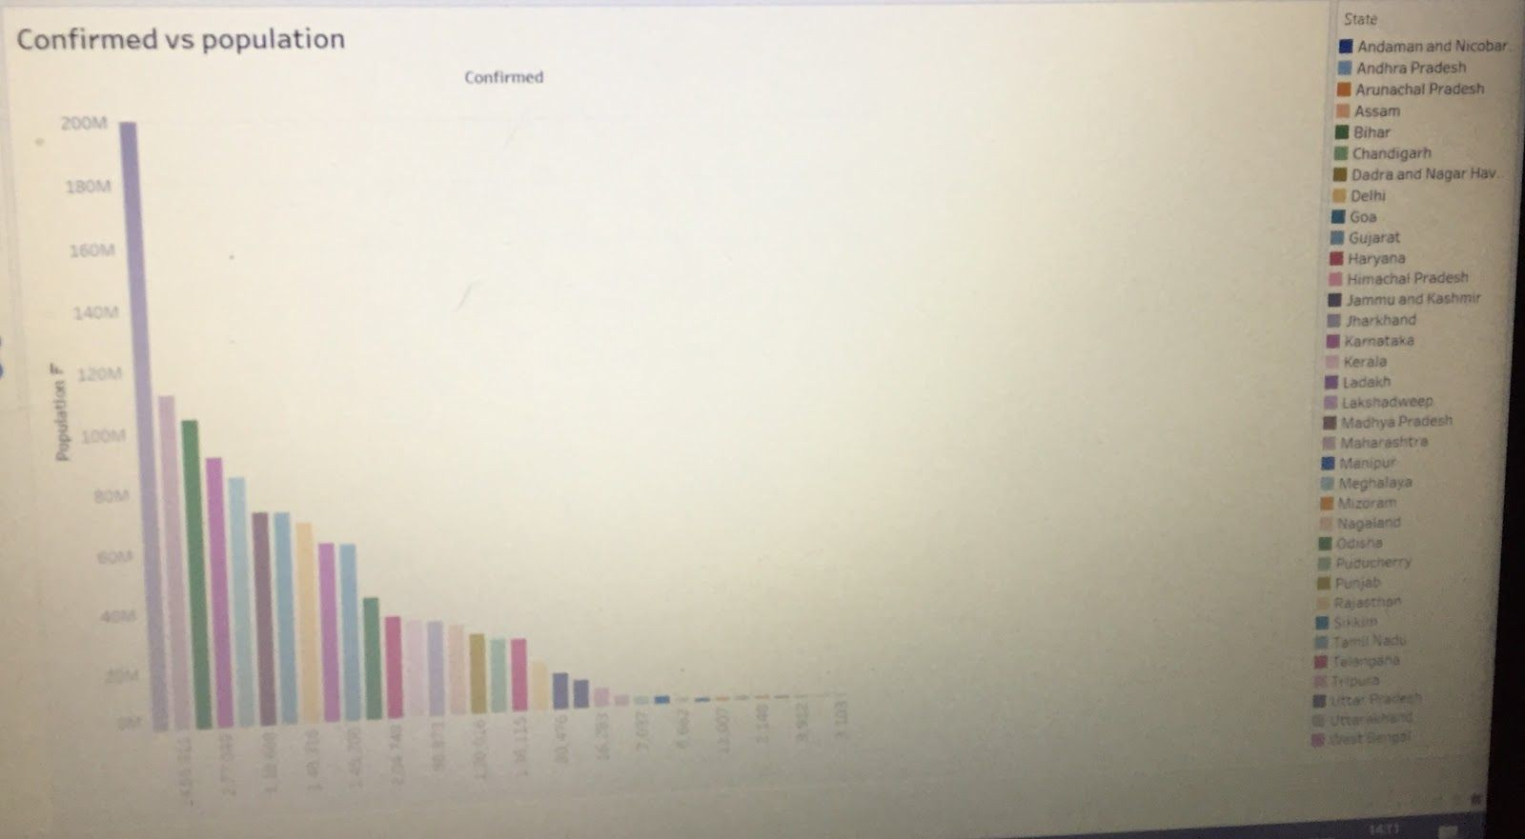

**Fig 2: Confirmed cases vs Population**

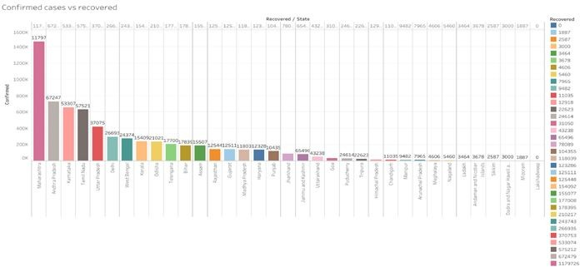

Fig 3 : confirmed vs recovered

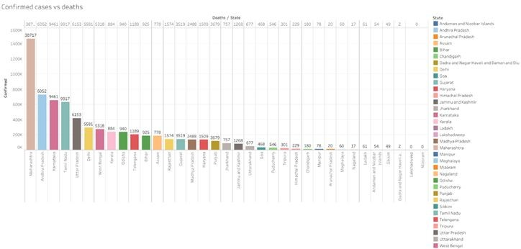

Fig 4 : confirmed vs deaths